Communications Toolkit
MSRGN Genetics Summit 2021: Connecting the Dots | November 9-10, 2021
Twitter: @GeneticMtnState | Facebook: @mountainstatesgenetics.org
Sample Email/Newsletter Text:
Mountain States Regional Genetics Network (MSRGN) Genetics Summit 2021: Connecting the Dots
November 9-10, 2021 | 9:30am - 2:30pm MT / 10:30am - 3:30pm CT
The MSRGN Genetics Summit 2021: Connecting the Dots is a virtual summit to educate, engage, and connect families, providers, and public health professionals around contemporary topics in genetics. During the summit distinguished speakers will be connecting the dots between disease and diagnosis, outreach, total value, and social perspectives. Speakers will cover a variety of timely genetics topics including the latest medical knowledge, clinical best practices, health care policy, reaching underserved populations, telegenetics, and more.
Register now to participate in the summit at no cost!
Sample Facebook Content:
Join Mountain States Regional Genetics Network November 9-10, 2021 for the MSRGN Genetics Summit 2021: Connecting the Dots, a virtual summit to educate, engage, and connect families, providers, and public health professionals around contemporary topics in genetics. During the summit distinguished speakers will cover a variety of timely genetics topics including the latest medical knowledge, clinical best practices, health care policy, reaching underserved populations, telegenetics, and more.
Register now to participate in the summit at no cost: https://bit.ly/37Q3jmL
Sample LinkedIn Content:
Join Mountain States Regional Genetics Network November 9-10, 2021 for the MSRGN Genetics Summit 2021: Connecting the Dots, a virtual summit to educate, engage, and connect families, providers, and public health professionals around contemporary topics in genetics.
At the Summit, we will:
- Educate within a multidisciplinary forum exploring the most recent medical knowledge and state, regional, and national initiatives in the field of the pediatric genetic services.
- Engage participants in timely genetics topics including clinical best practices, health care policy, reaching underserved populations, and telegenetics.
- Connect genetics professionals, non-genetics professionals, primary care providers, individuals and families, and public health representatives.
Register now to participate in the summit at no cost: https://bit.ly/3xYNrca
Sample Tweet:
Join @GeneticMtnState for the MSRGN Genetics Summit 2021: Connecting the Dots, a virtual summit to educate, engage, and connect families, providers, and public health professionals around contemporary topics in genetics.
Register now to participate in the summit at no cost: https://bit.ly/3gdViMW
Graphics to Accompany Content: 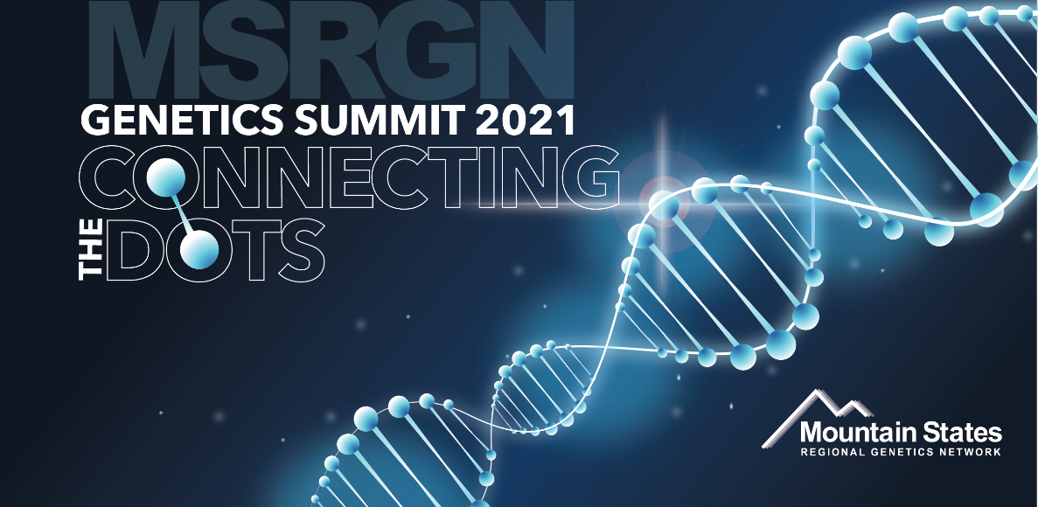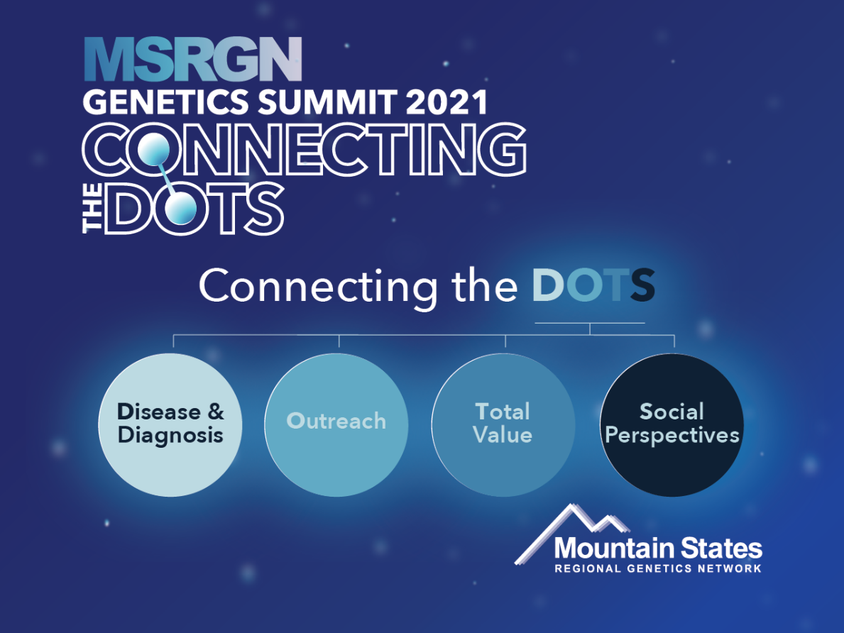

Speaker Specific Content

Sample Facebook Content:
​I’m excited to lead [Session Name] at the MSRGN Genetics Summit 2021: Connecting the Dots. Register at https://bit.ly/37Q3jmL to join me November 9-10, 2021 for the entire Virtual Summit.

Sample LinkedIn Content:
I will be presenting on [Session Name] at the MSRGN Genetics Summit 2021: Connecting the Dots. Register at https://bit.ly/3xYNrca to join me November 9-10, 2021 for the entire Virtual Summit.

Sample Tweet:
Join me at the @GeneticMtnState MSRGN Genetics Summit 2021: Connecting the Dots on November 9-10, 2021, as I present on [Session Name]. https://bit.ly/3gdViMW

