Promotional Toolkit

MSRGN Genetics Summit 2022: Momentum in the Mountains

Key links:
- Twitter: @GeneticMtnState
- Facebook: @mountainstatesgenetics.org
- LinkedIn: @mountainstatesgenetics
- Website: mountainstatesgenetics.org/events/gs22/

Key dates:
- Virtual summit: November 9-10, 2022

Graphics:
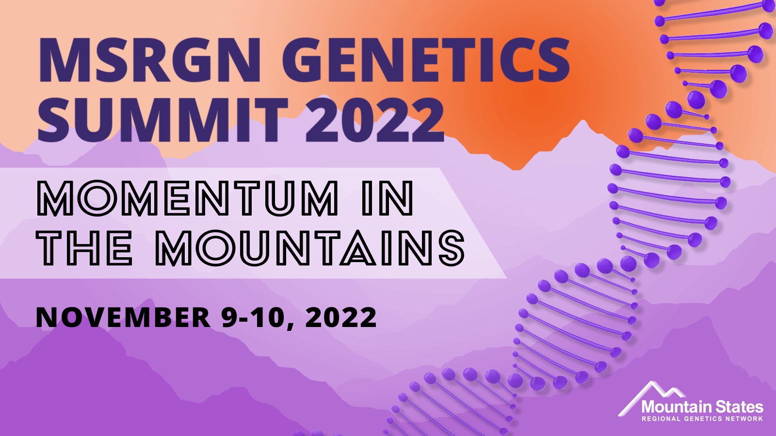

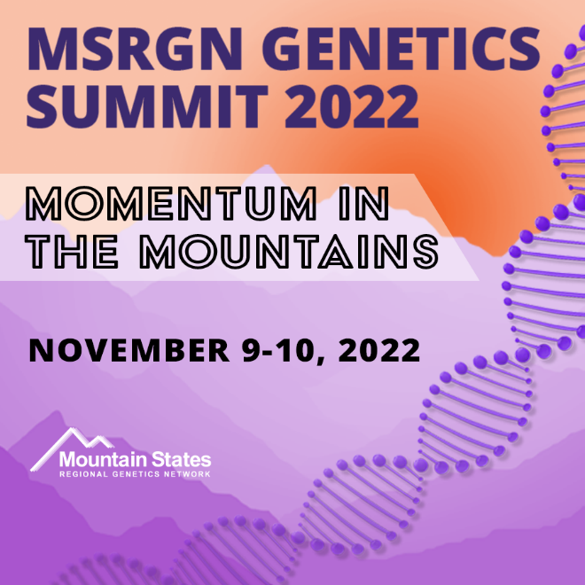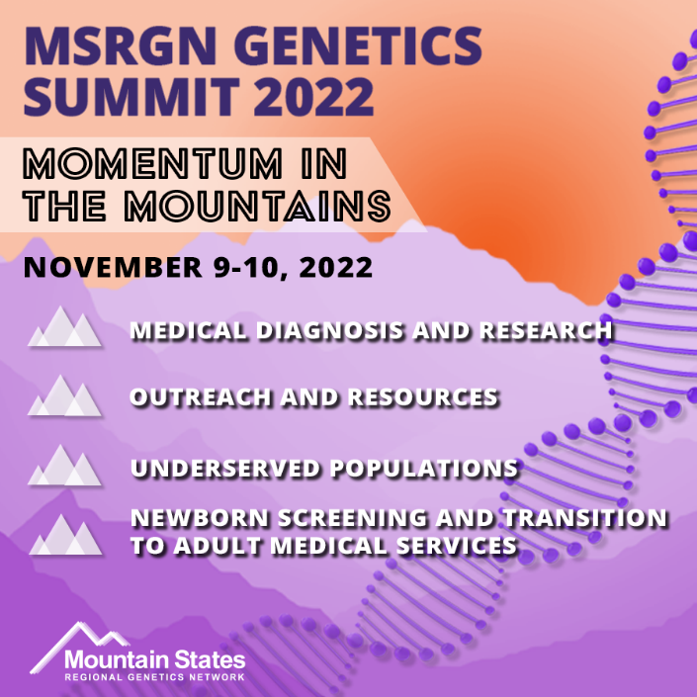

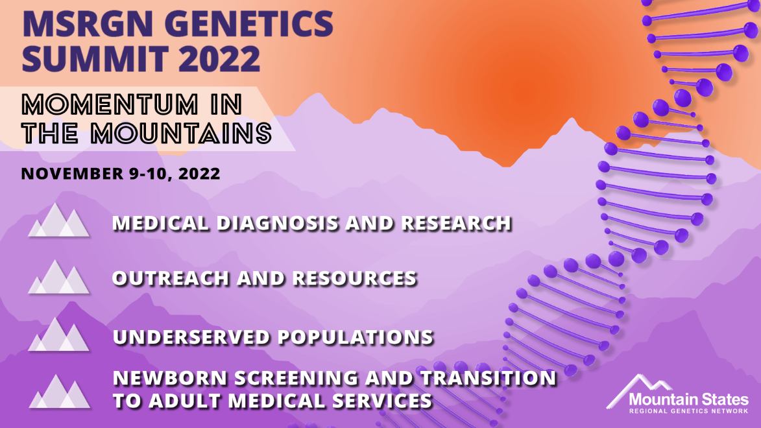

Sample Email/Newsletter copy:
MSRGN Genetics Summit 2022: Momentum in the Mountains
November 9-10, 2022 | 9:30am - 2:30pm MT / 10:30am - 3:30pm CT
The Mountain States Regional Genetics Network Genetics Summit 2022: Momentum in the Mountains is a virtual summit to educate, engage, and connect families, providers, and public health professionals around contemporary topics in genetics. During the summit distinguished speakers will cover a variety of timely genetics topics including medical diagnosis, outreach, underserved populations, newborn screening, transition to adult medical services, and more!
Register now to participate in the summit at no cost!

Sample Facebook/LinkedIn posts:
Join Mountain States Regional Genetics Network November 9-10, 2022, for the MSRGN Genetics Summit 2022: Momentum in the Mountains, a virtual summit to educate, engage, and connect families, providers, and public health professionals around contemporary topics in genetics. During the summit distinguished speakers will cover a variety of timely genetics topics including medical diagnosis, outreach, underserved populations, newborn screening, transition to adult medical services, and more!
Register now to participate in the summit at no cost: bit.ly/3dA6cOy

Join Mountain States Regional Genetics Network November 9-10, 2022, for the MSRGN Genetics Summit 2022: Momentum in the Mountains, a virtual summit to educate, engage, and connect families, providers, and public health professionals around contemporary topics in genetics.
At the virtual summit, speakers will focus on:
- Medical Diagnosis & Research
- Outreach & Resources
- Underserved Populations
- Newborn Screening to Transition to Adult Medical Services
Register now to participate in the summit at no cost: bit.ly/3dA6cOy

Sample Tweets:
Join @GeneticMtnState for the MSRGN Genetics Summit 2022: Momentum in the Mountains, a virtual summit to educate, engage, and connect families, providers, and public health professionals around contemporary topics in genetics. Register to participate at no cost: bit.ly/3dA6cOy

Register for the @GeneticMtnState summit to hear from distinguished speakers about a variety of timely genetics topics including medical diagnosis, outreach, underserved populations, newborn screening, transition to adult medical services, and more! bit.ly/3dA6cOy

Speaker Specific Content

Sample Facebook/LinkedIn posts:
​I’m excited to lead [Session Name] at the MSRGN Genetics Summit 2022: Momentum in the Mountains! Register at bit.ly/3dA6cOy to join me November 9-10, 2022, for the entire virtual summit.

I will be presenting on [Session Name] at the MSRGN Genetics Summit 2022: Momentum in the Mountains. Register at bit.ly/3dA6cOy to join me November 9-10, 2022, for the entire virtual summit.

Sample Tweet:
Join me at the @GeneticMtnState MSRGN Genetics Summit 2022: Momentum in the Mountains on November 9-10, 2022, as I present on [Session Name]. bit.ly/3dA6cOy

